**Echo Squad Solution Suite: Chinook Music Store Application Development progress**

**Introduction**

This document provides an updated comparative analysis of the Echo Squad's development journey with the Chinook Music Store Application, an integral part of the Team Echo Solution Suite. Post a strategic realignment and team restructuring, our approach now capitalizes on the distinct skills of each member, aligning closely with our Capstone course objectives. This comparison highlights the transitions from initial stages to current advancements, focusing on database integration, UI development, and feature activation within the application.

### Enhancements and Progress

#### Initial State vs. Current Development:

* **Database Connectivity:** Initially, the application featured a static UI without active database connections. Now, thanks to Entity Framework integration, we have progressed to a stage where dynamic content driven by database connectivity is in the pipeline, aiming to activate menus and data display features.
* **UI Evolution:** From a basic layout previewing menus and buttons, we have advanced to a stage where the UI design is refined, with plans to link UI elements directly to the database, enhancing visual appeal and usability.

#### Implemented Features:

* **Functionality Verification:** We have moved from confirming the theoretical implementation of functionalities to actualizing these capabilities within the application. This includes dynamic search functionalities across Artist, Album, and Track pages, now operational through LINQ queries.
* **Feature Additions:** The introduction of a Music Catalog page and a Customer Orders page represents a leap from mere planning to execution, offering databound GUIs for comprehensive data interaction and display.

**Instructor Approval and Guidance**

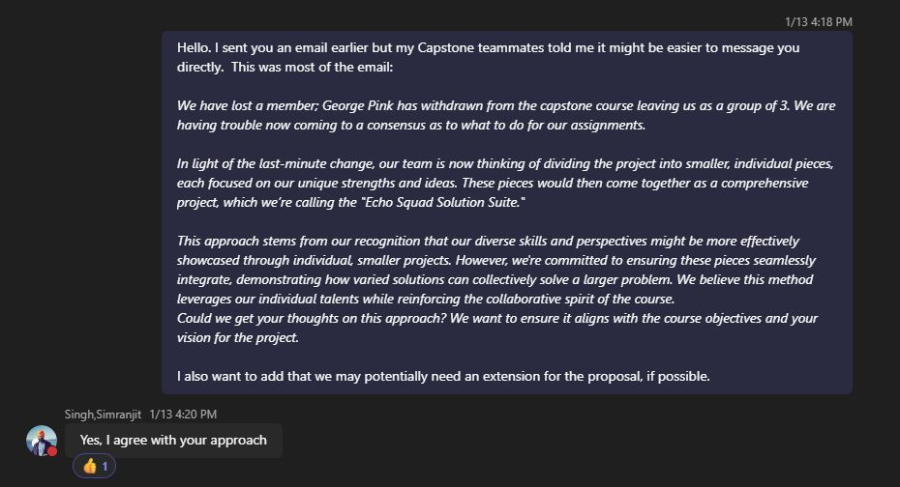

* **Direct Communication with Instructor**: Our revised approach, including a proposal extension request, was communicated, and endorsed by our instructor, Simranjit Singh.

**Continuous Team Coordination**

* **Weekly Reports**: Emphasized the importance of regular individual report submissions for consistent progress tracking and accountability.
* **Learning Contract Submission**: Adherence to the prescribed template for the learning contract proposal.

### Individual Contributions:

#### Comparative Insights:

* **Steven Crosby:** His journey from conceptualizing database connectivity enhancements to actively integrating the Entity Framework showcases significant progress in enhancing application functionality.
* **Phuc Huynh & Gregory Pomeroy:** Both team members have transitioned from initial research and struggle phases to substantial development contributions - with Huynh focusing on a Music Player API and Pomeroy on an audio visualizer, indicating a leap in project depth and technical expertise.

**Project Development**

**Application Overview**

* **Current State**: The Chinook application is currently in a stage where the user interface is static.
* **Objective**: The Entity Framework for database connectivity with the Chinook SQL Server database has been implemented,
* **Menus and Pages**: The application includes features such as 'Exit', 'Pages', and options like 'View All Artists', 'Albums', and 'Tracks'.
* **Data Display Pages**: Pages intended for displaying artists, albums, and tracks are set up but currently empty. Caption: "Preliminary User Interface Layout of the Chinook Music Store Application"

*Caption: “Current User Interface Layout of the Chinook Music Store Application"*

**Individual Contributions:**

**Comparative Insights:**

* **Steven Crosby:** His journey from conceptualizing database connectivity enhancements to actively integrating the Entity Framework showcases significant progress in enhancing application functionality.
* **Phuc Huynh & Gregory Pomeroy:** Both team members have transitioned from initial research and struggle phases to substantial development contributions - with Huynh focusing on a Music Player API and Pomeroy on an audio visualizer, indicating a leap in project depth and technical expertise.

**Knowledge Integration and Project Development:**

**Enhanced Application of Concepts:**

* The shift from basic application concepts to a more in-depth integration of database connectivity, UI design, and JavaScript demonstrates a broader and more profound application of course-related knowledge.

**Research and Development:**

* Our project has evolved from preliminary research efforts to a more specialized application of knowledge, particularly in areas like database connectivity and audio visualization.

**Compliance with Course Objectives and Team Collaboration:**

**Structural and Collaborative Evolution:**

* The project structure has become more logical and clear, showcasing our ability to organize, articulate, and collaborate more effectively as a team.

**Teamwork Dynamics:**

* Our teamwork has transitioned from forming stages to a more unified and collaborative effort, demonstrating an effective adaptation to strategic and operational changes within the project scope.

**Conclusion**

Through comparative analysis, it's evident that the Echo Squad has not only met but exceeded milestone #3 expectations, marking a significant progression in the Chinook Music Store Application development. Each team member's dedication to their segment, combined with our cohesive team strategy, underscores a well-researched, comprehensive, and collaborative effort aligning with our academic goals and project objectives. This journey reflects our extensive knowledge, rigorous research, and effective teamwork, positioning us for continued success in our Capstone course.